Key Findings of California Patient Safety and RC Staffing Survey
Survey conducted October/November 2011
Survey Analyst: Gina Giles-Oas , UC San Diego Medical Center
Summary Prepared by: Richard Ford BS RRT FAARC, UC San Diego Medical Center
Version: March 2012

Background
Respiratory care departments provide health care services aimed at the diagnosis, treatment, and support of patients with pulmonary impairments. Treatments include, but are not limited to the delivery of medical gases, aerosolized medication, airway management, secretion clearance, the provision of and liberation from mechanical ventilation, the assessment/evaluation of treatment, and the use of a variety of technologies to monitor the patients condition and effectiveness of interventions. In providing such services acute care hospital employ Respiratory Care Practitioners (RCP), licensed by the California Respiratory Care Board (RCB). The mandate of the Respiratory Care Board is to protect and serve the consumer by administering and enforcing the Respiratory Care Practice Act and its regulations in the interest of the safe practice of respiratory care. In recent years there have been an increase in the number of practitioners expressing concern that reductions in RCP workforce are jeopardizing the ability to provide safe care. Practitioners have solicited the intervention of both the California Society of Respiratory Care as well as the California Respiratory Care Board to establish guidelines, position statements, and possible regulation that would define critical considerations in staffing respiratory services.
When examining a hospital’s overhead costs with the purpose of making budget cuts, there is no getting around the labor factor. Labor costs continue to be hospitals' biggest expense and an area where job cuts can provide the quickest impact to the bottom line. RCPs provide services to the sickest population of patients and are integral to a hospital’s ability to provide care in areas such as the intensive care unit, newborn nurseries, trauma center, and emergency services. In serving this patient population, reductions in the RCP workforce beyond critical levels can result in missed therapy, misallocation of therapy, inability to respond, and errors that can result in negative outcomes, complications, and even patient death. This concern provided reason to better assess the status of staffing respiratory care. California managers were surveyed to report their perceptions of staffing level, the cause of staffing shortages, and practices in place that may directly impact staffing.
It is important to note the survey tool designed and utilized in California was originally utilized in North Carolina. The North Carolina Respiratory Care Board commissioned that project. The project was commissioned by:
Joseph Coyle, MD
Board Chair
NC Respiratory Care Board

Floyd E. Boyer, RCP
Executive Director
NC Respiratory Care Board

As a result of the survey, the North Carolina Respiratory Care Board issued a position statement to provide guidance about the Boards interpretation of the Respiratory Care Practice Act and the Boards Rules, as the Act and Rules relate to the establishment of respiratory staffing. The California Society for Respiratory Care opted to utilize the same survey tool as it was effective in the assessment of staffing and provides a means of comparing perceptions and practices. It is hoped that the results of the survey will guide the CSRC to adoption of similar position statements and guidelines that can be referenced by those making decisions about RC staffing. In the reporting of survey results for California, some of the North Carolina (NC) data is included for comparison.

California Results
Of approximately 440 hospitals in California, 130 centers (NC 33) participated representing responses from nearly 30%.

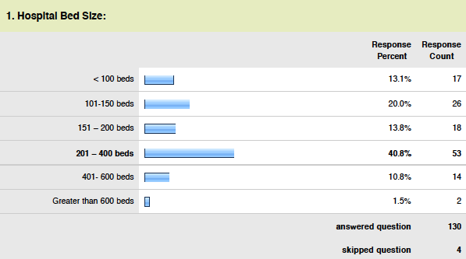
Assessment of bed size:
General profile information indicates 75% of surveys were from centers that were 400 beds or less.
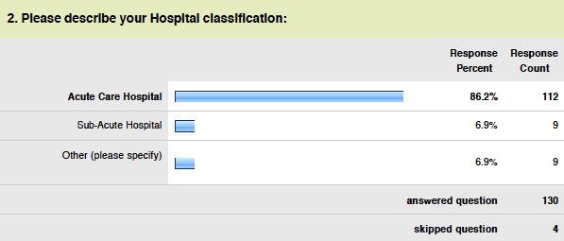
Assessment of classification:
The survey was distributed to various classifications of hospitals with nearly 87% of respondents from acute care centers. “Other” consisted of centers that were primarily both acute and sub acute.
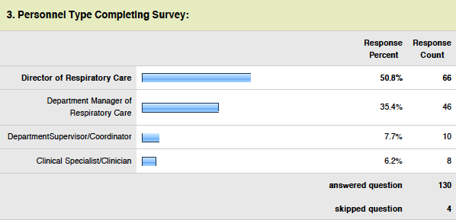
Assessment of personnel type:
All participants were in some type of leadership capacity and thought to be engaged with staffing management.
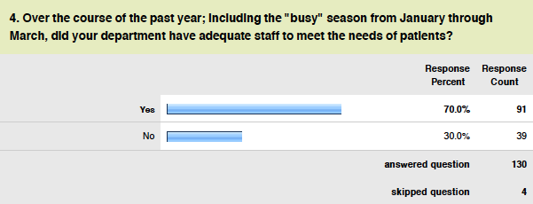
Assessment of past year staffing levels:
It was the general perception of 30% (NC 31%) of respondents they did not have adequate staff over the course of the past year. In such situation managers identified the need for additional staff in relation to patient need.
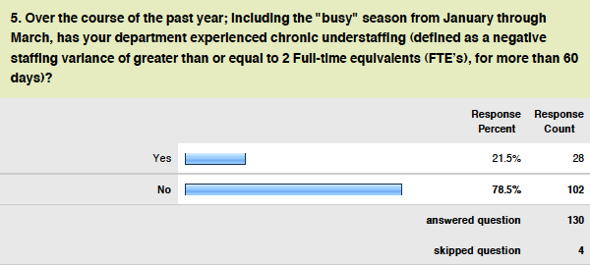
Assessment of experience of chronic understaffing:
It was the intent of question 5 to address the issue of being significantly understaffed on an ongoing basis, defined as a consistent shortage greater than 2 FTEs over 60 days. This would represent a more serious issue in which over 21% (NC 36%) indicated significant and chronic understaffing exists. This question clearly identifies that greater than 1 out of 5 centers are struggling with being understaffed on a chronic basis.
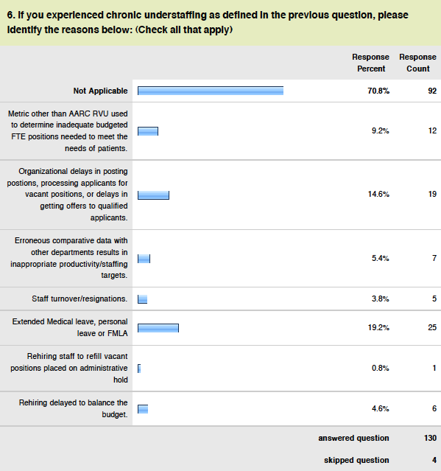
Assessment of reasons for being understaffed:
A key intent of the survey was to also identify the reasons for departments being understaffed. The most significant reasons for chronic understaffing were extended medical leave and delays in the onboarding process. The NC data also indicated extended medical leave as the most significant reason for being understaffed. 11% of those responding indicated the issue was the establishment of inappropriate staffing/productivity targets or other administrative mandate. Considering these data are a % of all 130 respondents the data was assess to reflect the % of each for those in which this question was applicable.

Reason | Count | %
Metric | 12 | 16%
Onboarding | 19 | 25%
Targets | 7 | 9%
Turnover | 5 | 7%
Leave | 25 | 33%
Freezes | 1 | 1%
Budget | 6 | 8%
 | 75 | 100%

One can assess that in for those who identified a reason for understaffing that 34% of the time it was a result of poor metrics, administrative targets, hiring freezes or budget related. For 76% of responders the key reasons for being understaffed were the result of more department/system issues related to managing leaves, turnover, and the processes involved in the recruiting/hiring new staff. This indicates that California Managers of Respiratory Care not only need tools that will help decision makers in setting staffing targets for the provision of RC services, but are in in need of better systems to manage leave, to flex staff up in response to leave, and improved the onboarding process.
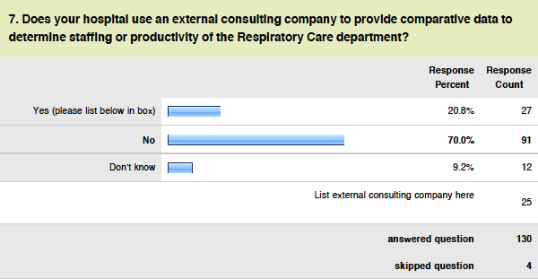
Assessment of use of external consultants:
There were 20% (NC 42%)of hospitals using external consultants in setting FTE targets. Indicating 1 out of 5 centers uses such services. Regarding changes in the reasons for being understaffed for those that have consultants the results were as follows:
Reason | Count | %
Metric | 5 | 21%
Onboarding | 6 | 25%
Targets | 2 | 8%
Turnover | 0 | 0%
Leave | 6 | 25%
Freezes | 1 | 4%
Budget | 4 | 17%
 | 24 | 100%

For those who indicated they do not use consultants:
Reason | Count | %
Metric | 5 | 12%
Onboarding | 11 | 26%
Targets | 3 | 7%
Turnover | 4 | 10%
Leave | 17 | 40%
Freezes | 0 | 0%
Budget | 2 | 5%
 | 42 | 100%

In those using consultants and reporting reasons for being short staffed, 50% compared to 24% of the time, it was a result of poor metrics, administrative targets, hiring freezes or budget related. These data would indicate that administrative targets are reasons identified for being short staffed to a much greater degree than facilities in which consultants are not employed.
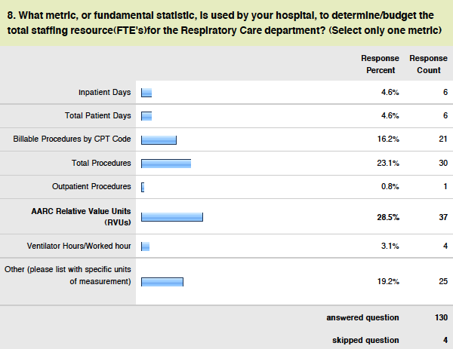

Assessment of metrics being applied:
The primary metrics being applied were the AARC Time Standards in 29% (NC 25%). In North Carolina the most widely used metric was billable procedures by CPT code in which 46% of NC hospitals reported as the fundamental metric to determine budget. In California this metric ranked third with only 16% of centers reporting its use as the fundamental metric. It is worth noting that the use of billable procedures by CPT code is identified in the AARC URM and in other forums as a metric that does not adequately reflect RCP activity. With NC reporting nearly double the use of external consultants it may explain why the use of Billable Procedures with CPT Codes is applied in a far greater % of hospitals. It is also observed that less than 10% (NC 5%) are using a global metric such as patient days or discharges, also considered inappropriate in determining staffing levels for RC departments.
Filtered analysis indicated for centers that employ consultants that in 21% of the situation the AARC URM time standards are utilized. The use of AARC time standards in facilities that do not utilize consultant is much greater at 32%.
Additional analysis was performed to better determine the relationship between chronic understaffing and the use of either patient driven or procedural driven metrics, considering procedural driven productivity metrics better account for respiratory care needs. For this analysis the entries made as “other” were included and classified as patient or procedure driven. The relationship between patient and procedure driven metrics was determined for centers that answered NO to being chronically understaffed and those that answered YES.
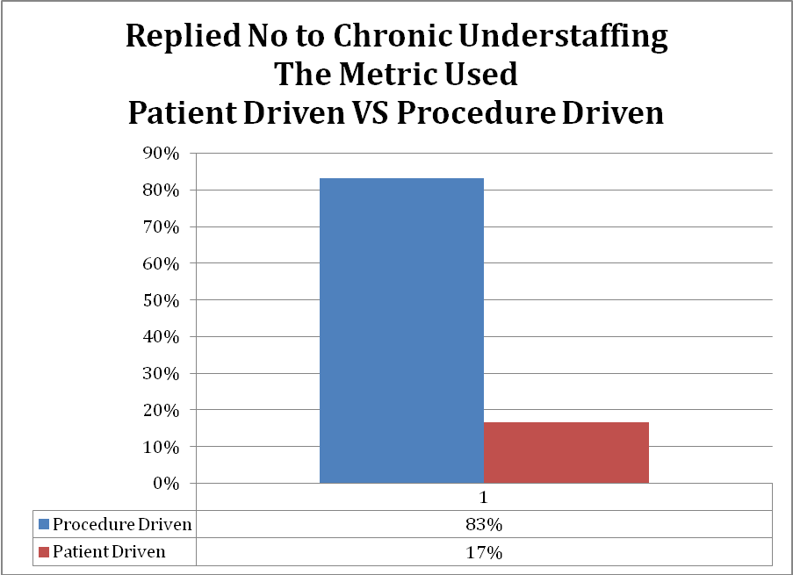
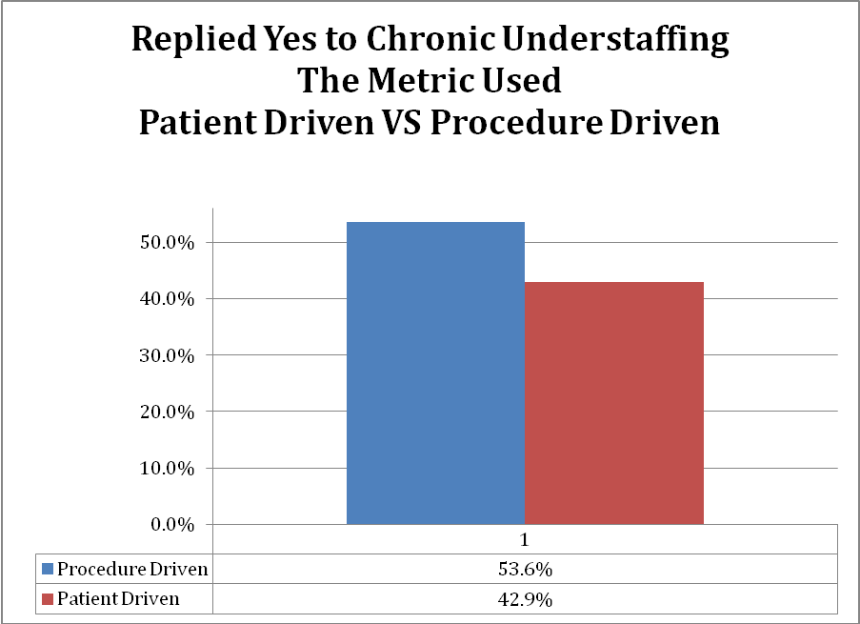
It is apparent that for those that report they are chronically understaffed there is a greater usage of patient driven vs. procedure driven metrics.
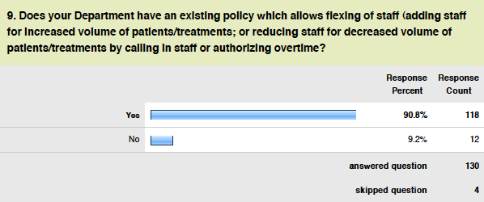
Assessment of flex staff model:
Over 90% (NC 84%)of departments reported a flex staffing model in place, however it appears the reasons for being short staffed remain unchanged, flex staff model or not.
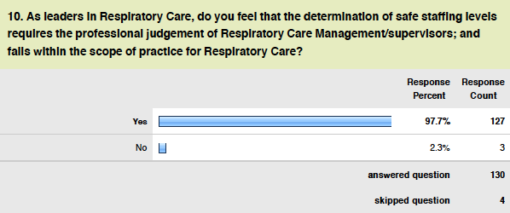
Assessment of leaders perception:
Nearly all respondents , greater than 97% (NC 100%), indicate it is within the scope of responsibility of RC Managers to insure staffing levels are defined and maintained. California managers appear engaged in being part of the solution to staffing issues.
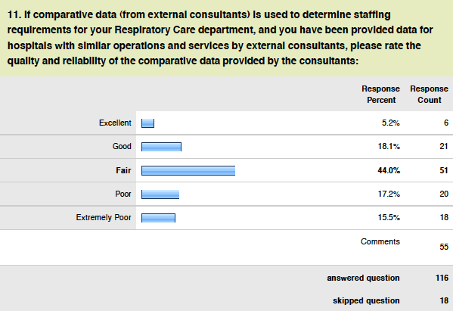
Assessment of quality and reliability of consultant data:
It appears data/metrics being applied to manage staffing comes from external sources. 116 of the 130 or 89% (NC 84%) responders indicated that such data is not very reliable (fair, poor, or extremely poor).
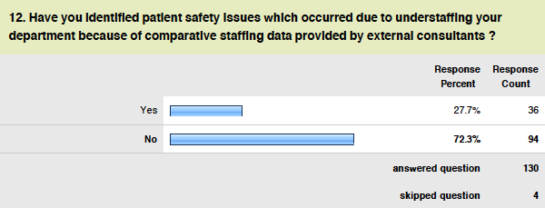
Assessment of perception of safety compromised by use of consultants:
Based on data provided by external consultants nearly 30% (NC 28%) of Directors felt at some point there were patient safety issues that resulted as a result of the applying such data and the impact on the ability to maintain required numbers of staff.
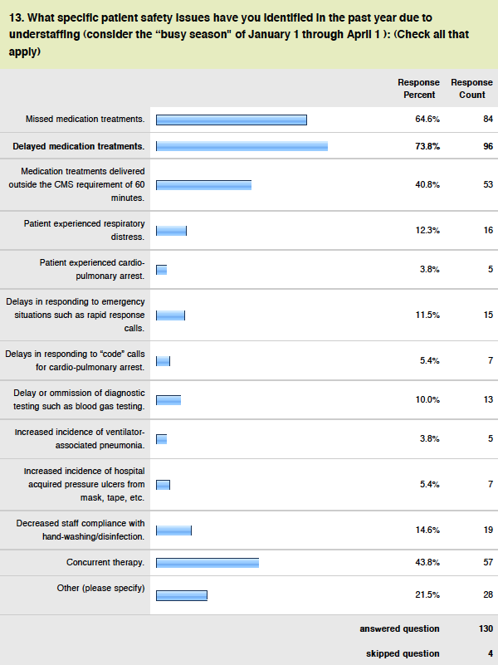
Assessment of patient issues:
In situations where understaffing exist there are a number of quality care issues that were identified. The most significant issues were delayed treatments, missed treatments, and delays beyond CMS guidelines. North Carolina was similar in reporting these issues as the most significant.
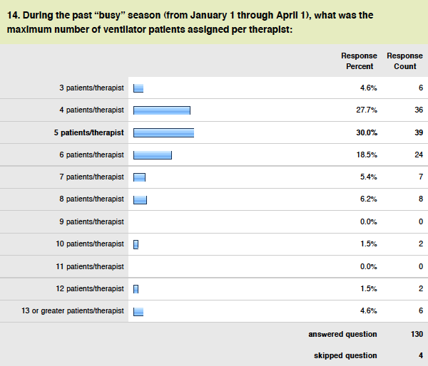
Assessment of vent ratios assigned during busy season:
Despite all the data capture and metrics applied to assess appropriate staffing, the number of ventilator assigned to an RCP during a shift is a simple and common indicator of work assigned. Applying the AARC URM standard, 4-5 ventilators per RCP would be a reasonable assignment. Data indicates that in over 60% of facilities, they set 5 or less ventilators as a staffing goal however many have set these assignment ratios even higher during the busy season.
Additional analysis was performed to better assess the relationship between ventilators assigned per RCP and the perception of being chronically understaffed. For departments that do not report being chronically understaffed the number of ventilator patients assigned per RCP are as follows:
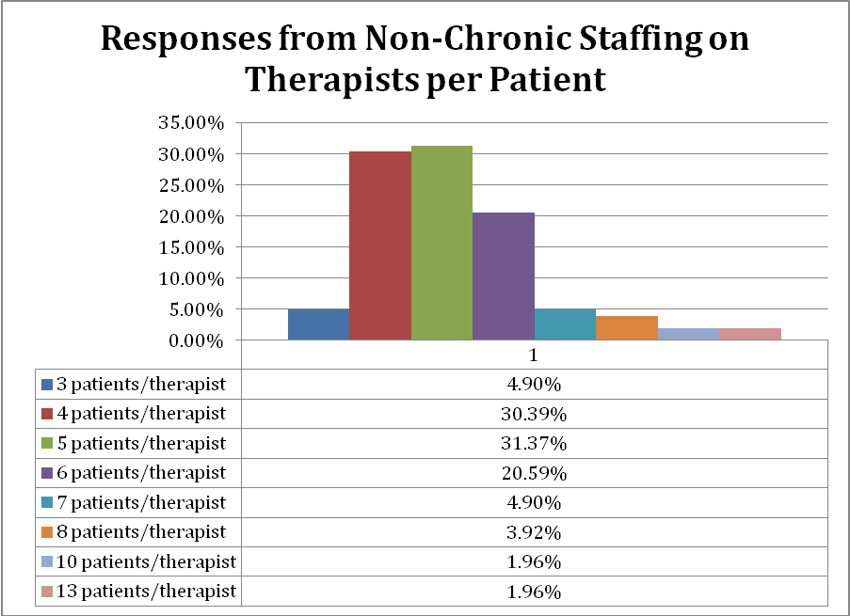
For departments reporting being chronically understaffed the number of ventilators assigned per patient is as follows:
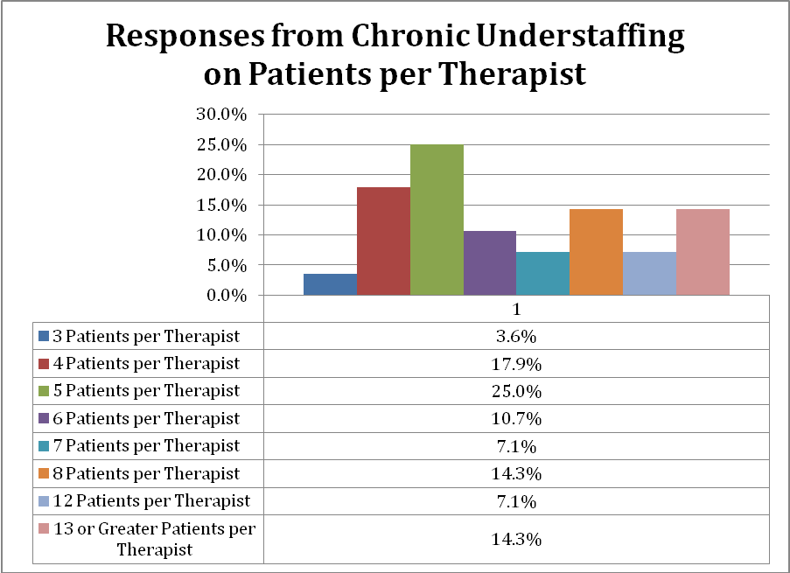
The data indicates that in departments the report they are chronically understaffed that staff is assigned more ventilator patients. With nearly 60% assigned greater than 5 vents and over 35% assigned 8 ventilators or more. This also demonstrates that regardless of the metric applied that ventilators typically consume a large component of the RCP workday and can be used as a simple metric in the assignment of work and assessment of productivity.
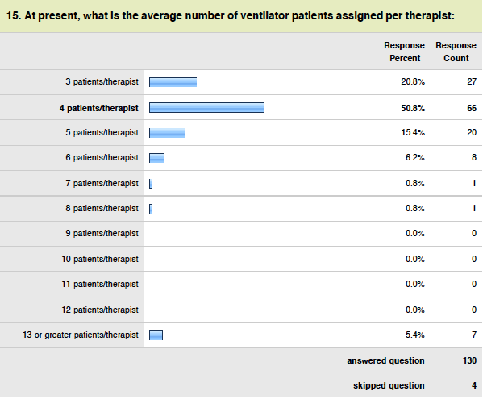
Assessment of average number of ventilators assigned:
The average number of vents assigned is much more in-line with the AARC URM time standard. The reality is that the ideal assignment cannot always be facilitated during the busy season as identified in the previous questions. During the busy season actual ventilator assignments were in actuality 1-2 greater than the staffing plan indicated.
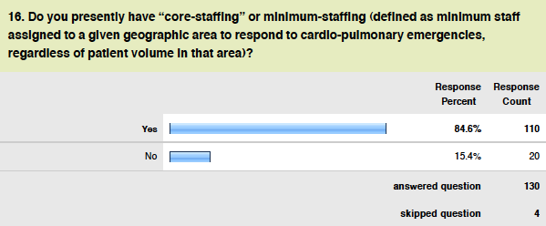
Assessment of core staff:
It appears the greater majority of departments have a program in which minimum staffing levels are identified so that coverage can be provided regardless is justified by work units.
The survey also asked the question: As leaders in Respiratory Care, what suggestions do you have to control healthcare salary costs while providing staff staffing levels for your hospital. Those comments are reported as entered. (inclusive of misspelling)
- Partnership with a union to educate them and understand the nature of our profession and the unpredictability of our workload. Then develop a strategy to meet the demand of the work. there is no longer seasonal workload in my opinion and I am just fortunate to have wonderful professional who understand the budget and are flexible with schedule.
- Control salary costs in the nursing profession.
- (1) Flexing, (2) On-shift education and competencies, (3) per diem staff
- Have respiratory therapist attend to the care of all trach patients . Make sure you staff 12 ventilators no more to a therapist. Make sure the staffing of nursing is pertaining to the delivery of medications and nursing scope of care and this will prevent lawsuits improve safety of patients and provide a productive rehabilitee facility. When you give better care to patients and rehab is effectual , patients go home new ones come in.
- Expanded responsibilities for qualified RCPs.
- Get rid of the LVN-RTs and keep RTs
- provide instruction and consultation for nursing staff to give routine HHN care in event RCP is not available.
- Leadership staff needs to be in touch with working staff on a shift to shift basis to manage the workload, increase or decrease staffing levels.
- Implement protocols hospital wide (ventilator weaning, HHN to MDI conversion, O2 protocols, Asthma treatment protocols) to decrease RCP workload and patient LOS.
- We have a wage range for RCP, CRT and RRT. Having the higher credential should be acknowledged with a higher wage.
- We are a unionized hospital. Salaries are negotiated every 4 years
- Quantify RCS services
- Assure we are performing evidenced-base medicine
- Setting one standard for RCPs - RRT and seriously consider the Bachelors degree as the min.
- TDPs are necessary. Sharing staff within the same hospital systems.
- patient treatment frequency not always justifiable, patients under multiple treatments. HHN, MDI and DPI
- Only provide respiratory therapies/services that are indicated by clinical condition of the patient. Implement therapist driven protocols, ventilator weaning protocols, and insure that patient is an appropriate level of care based on clinical condition.
- Eliminate unnecessary overtime, reduce inappropriate sick time utilization, maintain large per diem and part time staff who wish to flex hours based on staffing needs.
- Eliminate unnecessary levels of management or other non-patient care providers.
- Assure procedure or service time standards match community or national standards.
- Wages and Salaries Increase across the board. And staffing according to procedures not census.
- A core of full-time staff that provide mostly specialty skills i.e. NICU, PFT, Bronch. Have an effective pool of per diem staff to cover adult care thereby reducing benefit costs. Adjust staffing shift-to-shift according to department determined time units that safely cover patient care.
- Cap Salary increases after a fix rate.
- respiratory therapist for ventilator/trach patients. nurses should stick to med passing/nursing care.
- None. Facilities, especially sub-acutes have reduced rcp staffing by 50%.
- Policy addresses Triage of Resp Care
- Educating leadership on value of RT in diversity of practice and the ablity to decrease long of safe, decreasing admission rate, decreasing HAPUs, decreasing VAP
- Diversion of general therapy procedures to nursing personnel with RT focusing on critical care environments.
- Put respiratory therapy in critical areas
- Bring back registry: limit overtime and stop burning out the staff. Lots of OT in the winter usually = lots of sick calls later on. Make the change to Q4 vent checks; make it clear what must be done with the time (assessment, weaning, bronch hygiene, look at CXR's/ABG's/I+O, present at rounds, participate in EBP /journal club activities). Then, when a patient needs extra care, or admissions skyrocket, you actually have the staff available to cope with it.
- Hire experts, professional therapists
- Leaders should help with the floor care too.
- Establish national standard RVU's.
- Avoid registry use and hire per-diems to fill the gaps.
- protocols to make sure that only the patients that "need" the care receive it
- We use per diem staff extensively. The goal is to have approx. 20% of our staff be per diem on any given shift. This allows us to flex down if needed. Since we have a significant per diem pool, it also allows us to flex up without the use of OT
- Increase the use of Therapist/Patient-driven Protocols.
- Reduce use of overtime by allowing the Department Leaders to determining the FTE utilizing validated data e.g. AARC Benchmark data.
- therapist-driven protocols
- Consider the inclusion of Respiratory Care Practitioners in the state mandated licensed care give to patient ratios in acute care hospitals. This would relieve the reliance on nursing as the only discipline considered in the caregiver: patient ratio. RCPs are educated and trained to monitor patient condition and can perform many of the nursing functions per their scope of practice.
- Bargain better with Union to control costs.
- RT training programs to continue to produce qualified graduates to meet labor market demands and to reduce use of expensive contracted/registry personnel.
- Have systems like EPIC be more like Medi-serve so the RCP can chart quickly and efficiently, and is reminded if he forgot a charting piece.
- Charge or Lead staff will be deployed more to the bedside in ICUs to better direct and coordinate care so that RCPs can better manage areas and not numbers or tasks. Also to reduce non-value added variations in care that are not evidence based.
- Making sure you have a balance between new grads and experienced level personnel.
- Implement protocols
- I believe minimum staffing levels for RCP's should be mandated by the State to remove the option for chronic understaffing as a budget balancing tool.
- There is a glut of RCPs entering the marketplace. As such, salaries are depressed so costs can be kept lower. Flexing staffing according to acuity, both up and down maintains costs as well.
- Better definition of and follow through with respiratory care duties
- Having sufficient staffing resources to help supplement staffing when needed would greatly help manage salary costs. This would help avoid having to use agency staff or premium pay (OT, Double-time, etc.)
- cross training of staff, so they can work any hospital area.
- Reduce the number of corporate administrative personnel and the top1% of the top earners wages to no more than 8- 10 times the bottom paid workers.
- Allow us to track and bill for RT time at the bedside. We are constantly asked to provide services which we cannot capture, but are vital to patient care.
- Pay Per Performance. Start with procedures performed, increase for patient compliments, decrease for patient complaints. Increase for education participation(being an instructor) and on-call responses, decreases for sick calls. Increase the number of Per Diem staff.
- Staff by Acuity, not census
- Salary costs are not a big issue compared to low reimbursement or no reimbursement for our services.
- Get rid of Unions
- Use patient driven protocols.
- Breath actuated nebulizer
- Have to relook at all the union contracts in place. Some may be too generous while others may be sub-standard for the geographical region. An example is shift differentials. Some follow a flat dollar amount (eg. NOC $2.95/hr) while others follow a percentage which is more on par with nursing shift differentials.
- Set staffing ratios
- Ability to flex down in RT staff when the patient care census is low.
- Flexing staff up & down according to acuity
- Prevent overtime and registry hour.
- provide only evidence based procedures
- Staffing guidelines for long term care areas would be nice.
- Bedside RTs must have an active hand in helping to manage the staffing levels. Shift-by-shift estimates of staffing need may be determined by counting procedures but those closer to the bedside know the individual patient needs. Safe, efficient staffing levels depend upon the input of bedside therapists.
- Hospitals are required to meet financial budgets so it is passed to all departments. it is not reasonable to have set matrix like the ones nurses have. Set up regs that state what RVUs should be and what tasks should receive RVUs then setup staffing standards that will allow for flexibility vs the set staffing matrix that nurses use. It has costs the hospitals millions of dollars to maintain these staffing standards for nurses plus the negotiated salaries and benefits. Salary costs and benefits need to be fair BUT out of the control of the UNIONS. We use RVUs here but are held to a very tight staffing standard by our corporation. Many times we do not meet productivity because the standard is too tight.
- Use creative staffing patterns to schedule staff. For example if your busiest time of the day is 10:00am to 7:00pm why not create a shift that reflects your workload and not just staff at 6-6 (12hour shifts) or 6-2, 2-10 and 10-6 (8 hour shifts). To often we find ourselves doing the same old thing because that is how it is always done. This is not easy to do because you interrupt people’s lives. Start small if you create a shift that is unusual start by asking for volunteers if not use your Per-diem staff and offer them to work those hours. That way you are having staff come in when you need them. You may be able to cut 4 to 6 hours of staffing a day per unit. We also started placing people on call as a safety net. When the workload is too close to call we will put someone on call with the provision they have to be at work within one hour of being called in. This provides additional safety without the paying for an extra person to actually be there. If you need them then you have to pay them callback wages if not you had the safety net in-place but only needed them the few dollars for them to be on call. Some of the staff love to be on call, they feel it is better than being cancelled.
- A standardized system to include billable AND non-billable procedures. ALL time spent with patients should be considered for the staffing component of the budget process.
- Enforcement of the 4 ventilators per RCP staffing rule that is currently only specific to respiratory ICU's
- National standards for minimal staffing for R.T. need to be established. Similar to what RN's use.
- If staffing was adequate we would encounter less overtime. The workflow for RT is not well understood by other professions in the hospital.
- Disband the Unions.
- Utilization of the AARC Uniform Reporting Manual as staffing guideline.
- Hire more per diems and do not use registry
- Hospitals offer some kind of early retirement incentive. This could potentially decrease sick calls and the use of overtime.
- Increase the use of protocols to control unnecessary therapy; Eliminate waste in facility processes; Work collaboratively with nursing to assure that the patient receives safe, timely and quality care at all times.
- Use of protocols to reduce unnecessary therapy
- Implementing workload models that optimize productivity with a balance of billable and non-billable procedures. Standbys for cardiac support, transports, cath lab, MRIs, etc.
- Ensure that staff is managing their time adequately and that workflows are developed that support proper time management.
- Key is managing utilization with protocols

End of report

